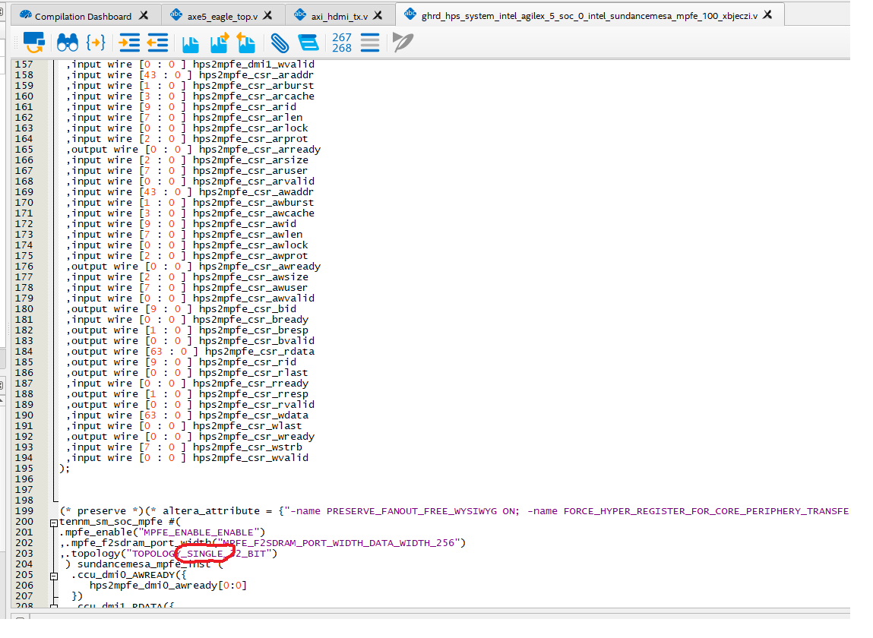

PD auto generated file incorrect spelling causes build error. TOPOLOGY_SIGNLE_32_BIT.

D:\intelFPGA_pro\23.2\ip\altera\intel_hps\sm\mpfe\intel_mpfe_sundancemesa_hw.tcl lines 58

D:\intelFPGA_pro\23.2\ip\altera\intel_hps\sm\mpfe_lite\intel_mpfe_lite_sundancemesa_hw.tcl lines 41